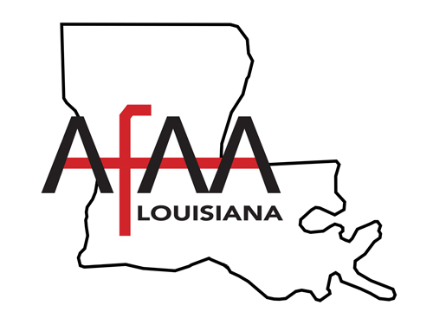
Louisiana Automatic Fire Alarm Association, Inc.

President’s Message
June 2026

Hello members and friends of the Louisiana Fire Alarm Association.

I hope everyone and their families had an enjoyable Memorial Day weekend.

In just a couple of weeks new we will be holding our Summer 2026 meeting. The meeting will be held on June 19th starting at 8:30 A.M. Please note that this meeting will be held at the Petroleum Club 111 Heymann Blvd, Lafayette, LA, United States. Our board meeting will be held at Don’s Seafood 4309 Johnston St, Lafayette, LA 70503 starting at 6:00 P.M June 18th. Anyone interested in potentially joining the board at some point in time, please contact a board member and attend our Thursday night meeting.

Our new board members have worked very hard to mix varying degrees of material to present to our members. We are trying to make sure we reinforce some of the basic fire material and present new and exciting technology that is what we believe to be the next generation in fire alarm some members may not have been exposed too.

For our Summer 2026 meeting, we will have presentations from the following presenters:
Chris Ralston -Ditek (in Person)
Lane Evans -Hanwha Camera - Early Fire Detection (in Person)
Maria Marks -Cybersecurity (Remote Presentation)
Maria Marks -NFPA 72 Code Updates (Remote Presentation)

And last but not least, the association would like to thank our sponsor for this meeting- Brent Wilkins (Kidde Commercial). Without help from our great sponsors, it would be very difficult for us to continue the quality of meetings our members have come to expect.
Thank you,
Gene D. Osborne

Gene Osborne
President

Brad Boudreaux
Vice President/Secretary

Shane Seaux
Treasurer

Archie Lejeune
Director
Eastern Region

Pam Pellegrin
Director
Western Region

Frank Gardner
Director
Northern Region

Don Law
Director-At-Large

Glenn McCollough
State Fire Marshal Liaison

Bryton Thompson
Education Chair

“Smoke Detectors AND Fire Sprinklers Save Lives”

7515 Jefferson Hwy, #16
Baton Rouge, LA 70806
225-924-1073
www.laafaa.org
501(C) (6) Non-Profit Corporation
Federal Tax Identification Number 72-1233461

